PUPIL SCHOOL MEALS –INTERNET PAYMENTS
1. From the Bridgend County Borough Council Home Page, Select the ‘Pay it’ option as indicated below:
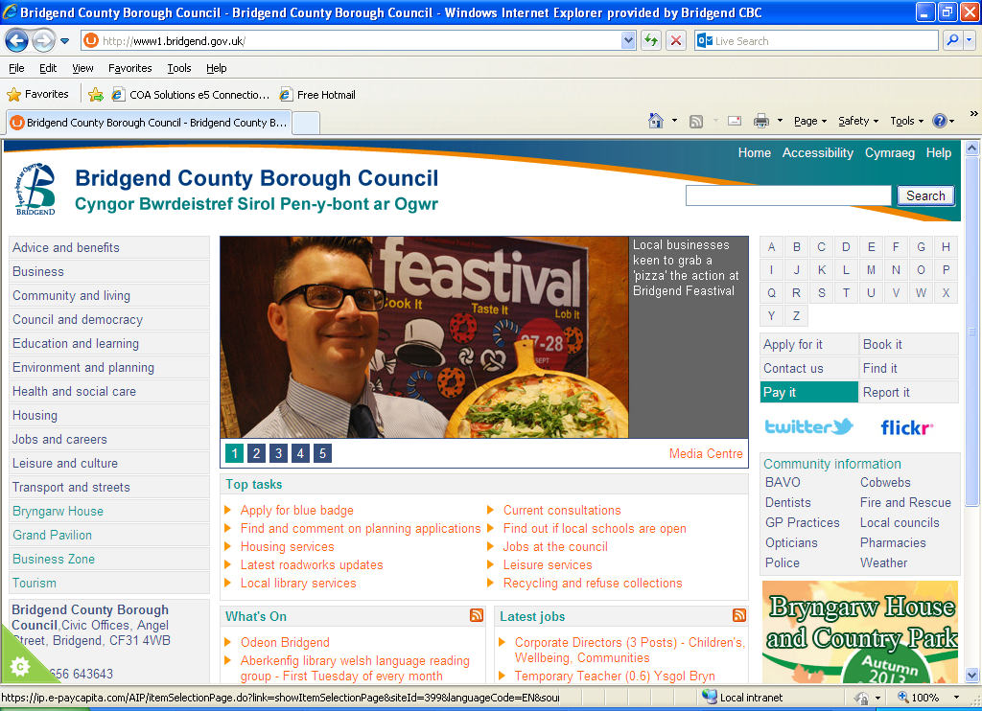
2. You will be directed to the Authority’s Payments Page. Select the ‘ Primary School Meals’ option, as indicated below:

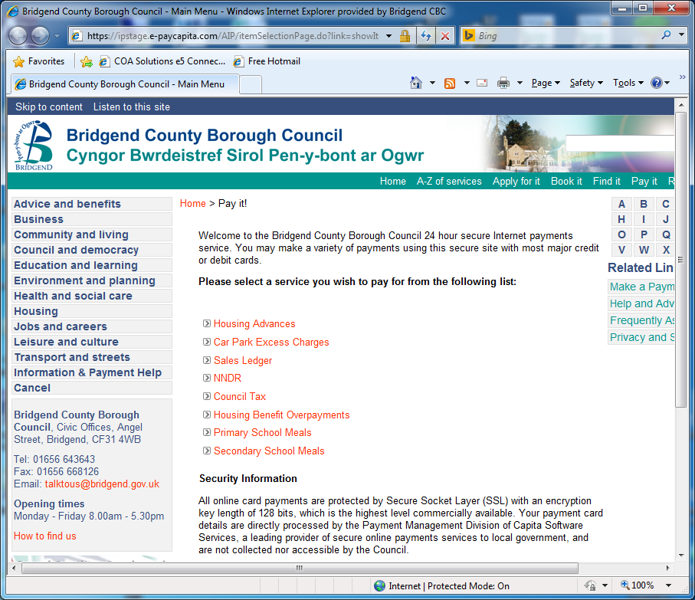
3. From this option you will be directed to a list of schools. Select the required school from the list as indicated below:
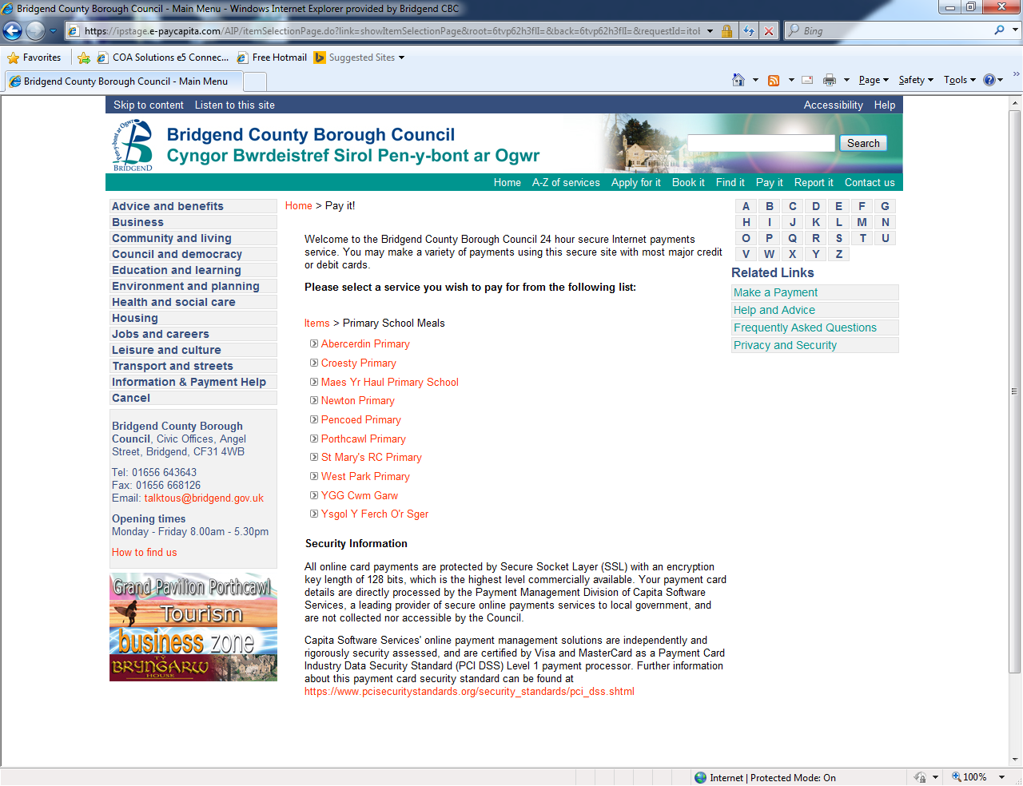
4. The below page will be displayed. Select the ‘Pupil School Meals Option’ as indicated:
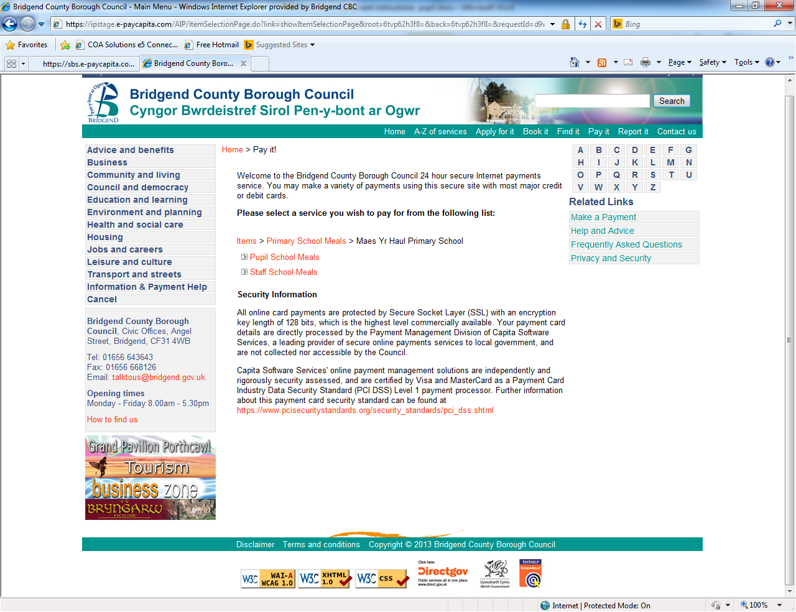

5. You are now at the stage of starting the payment. Enter the ‘Pupil Number’, ‘Pupil Forename’, ‘Pupil Surname’ and ‘Amount’. Once completed select the ‘Continue’ option as indicated below.
Please be aware that ALL fields are mandatory and must be completed to make a payment.
NB. THE PUPIL NUMBER IS THE NUMBER THAT HAS BEEN PROVIDED TO YOU IN THIS DOCUMENTATION
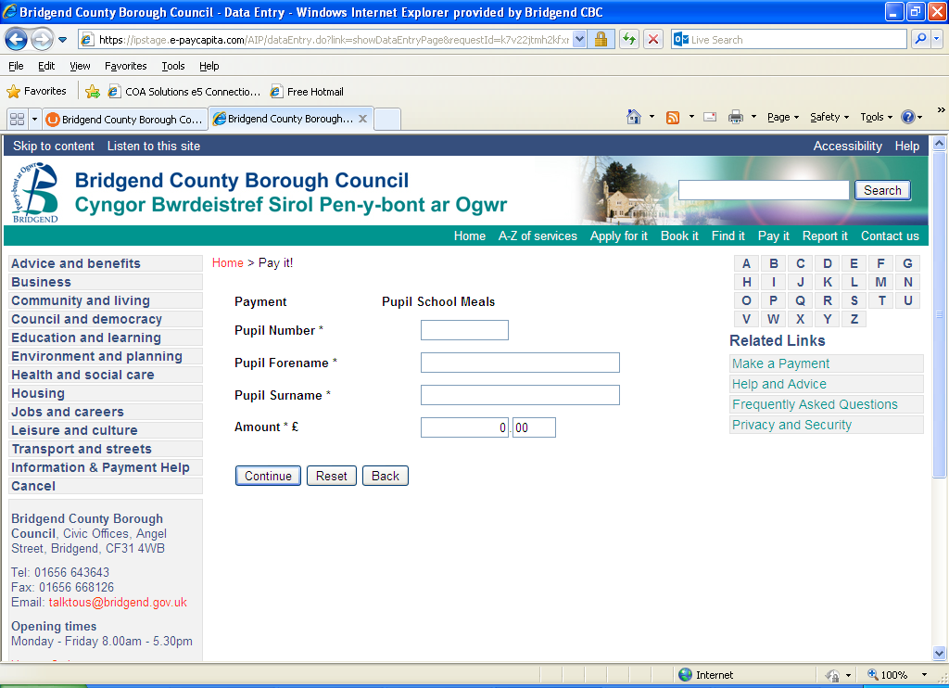
See below example of a completed page:
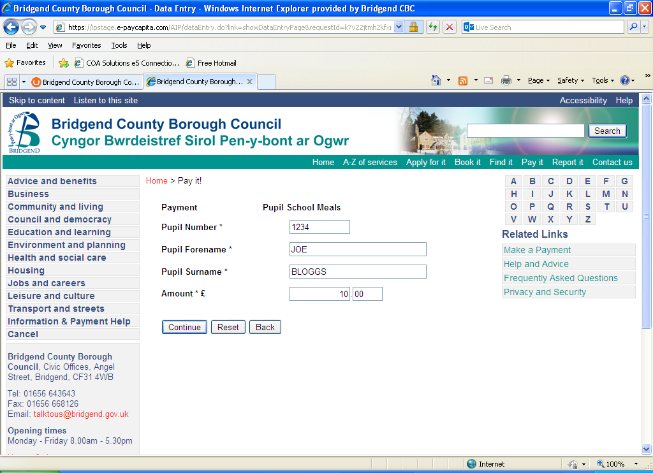

6. You will be presented with a page where you clarify the details entered. To continue with the payment select the ‘Continue’ button as indicated below.
To top up another pupil’s account within this transaction select ‘Add Another Service’ and repeat steps 2-6 of these instructions.
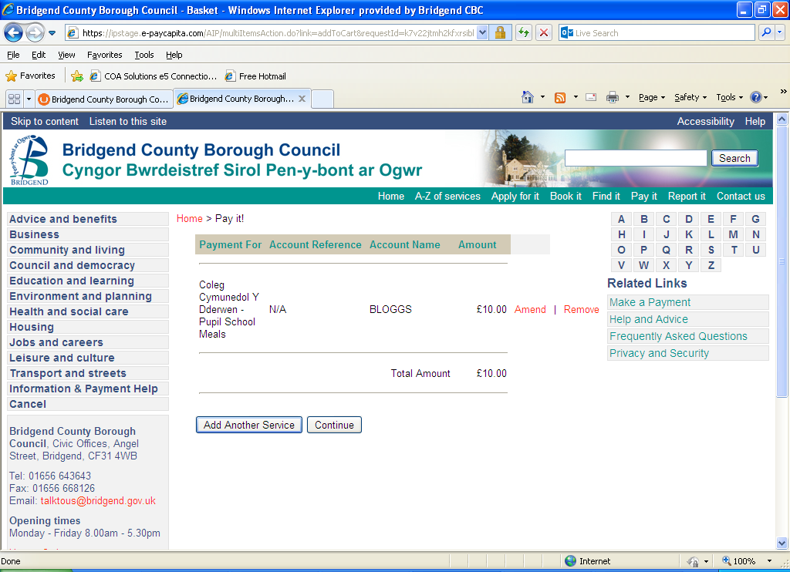
7. Once you have opted to continue, the payment card screen will be presented to you. Please enter your details and select the ‘Continue’ option as indicated below.
NB: The pupil name will default through to the ‘Card Holder Name’ field. Please remove this and replace with the name stated on the payment card.
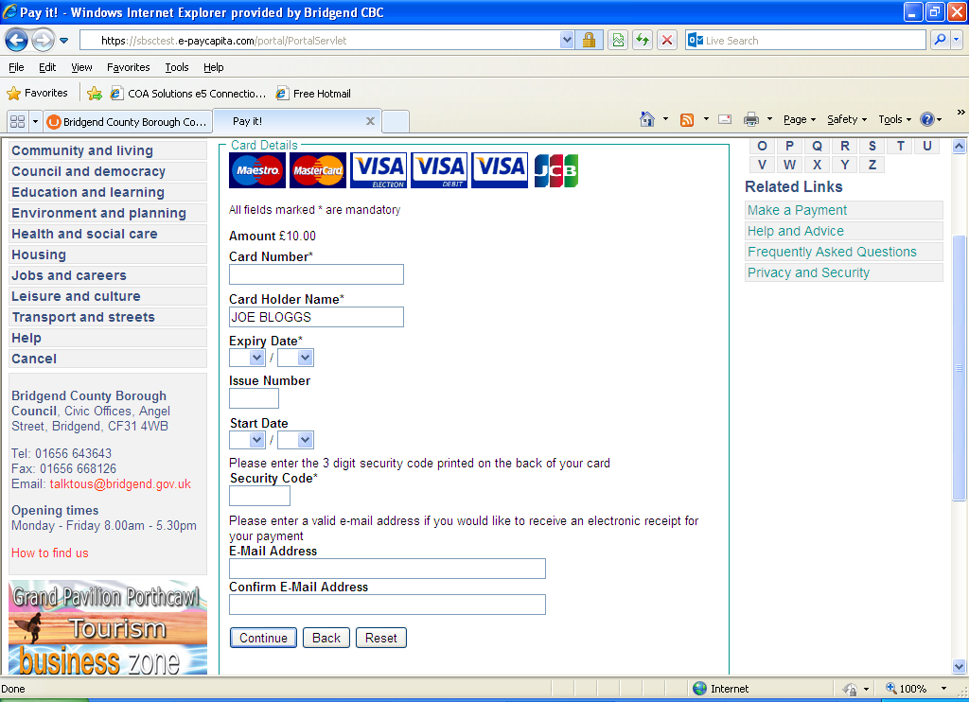

8. Below is an example of a completed payment card page. By entering your email address a receipt will be sent to you confirming your payment.
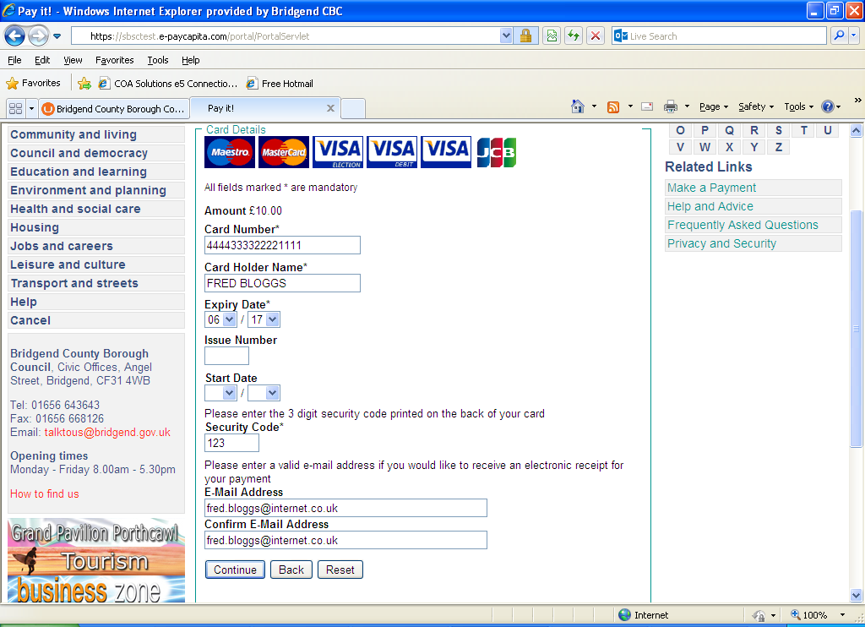

9. The following payment confirmation screen will be presented to you. Select the ‘Make Payment Option’ as indicated below:
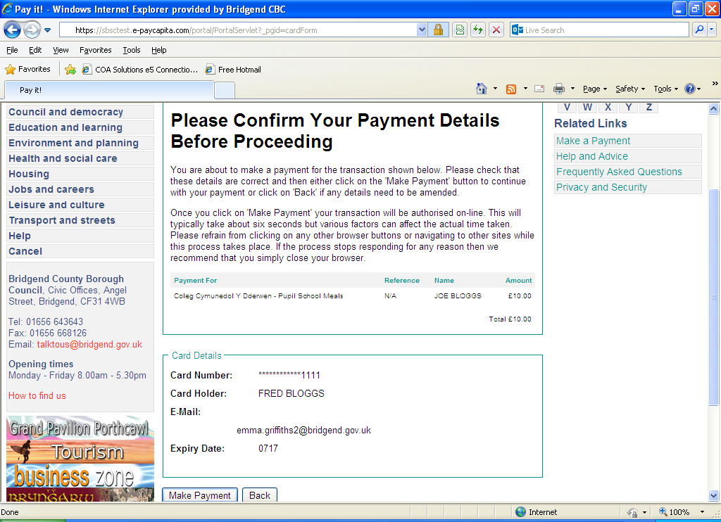

10. Once the payment is successful the receipt page will be displayed.
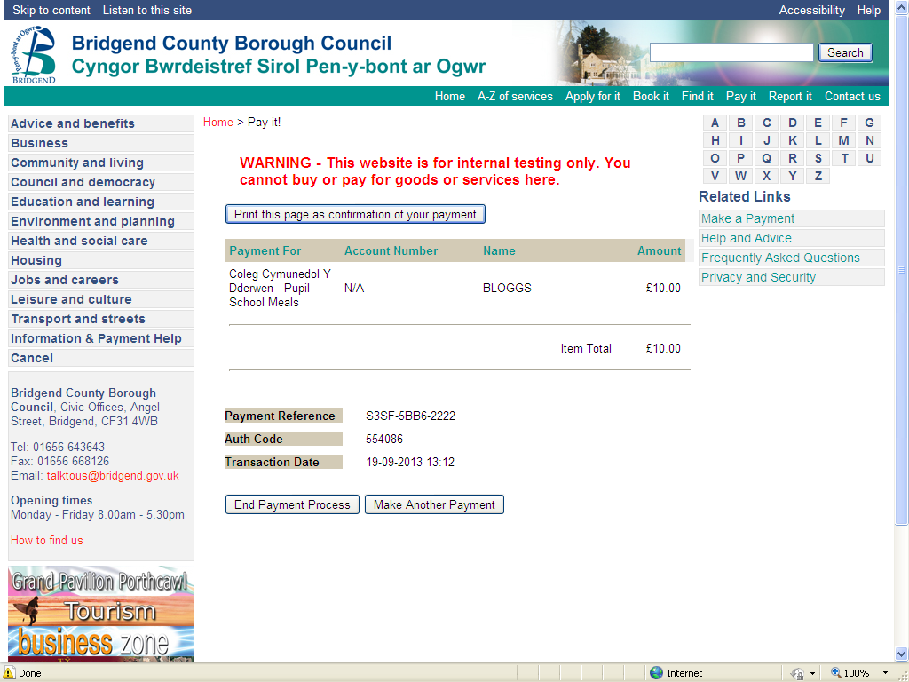
IT IS IMPORTANT THAT YOU GIVE 24 HOURS FOR THE MEAL ACCOUNT TO BE UPDATED AFTER PAYING VIA THE INTERNET

